**EXPERIMENT 4**

**RELATIONAL MODEL FOR SAILOR BOAT DATABASE**

**Aim:** Draw a relational model for sailors database.

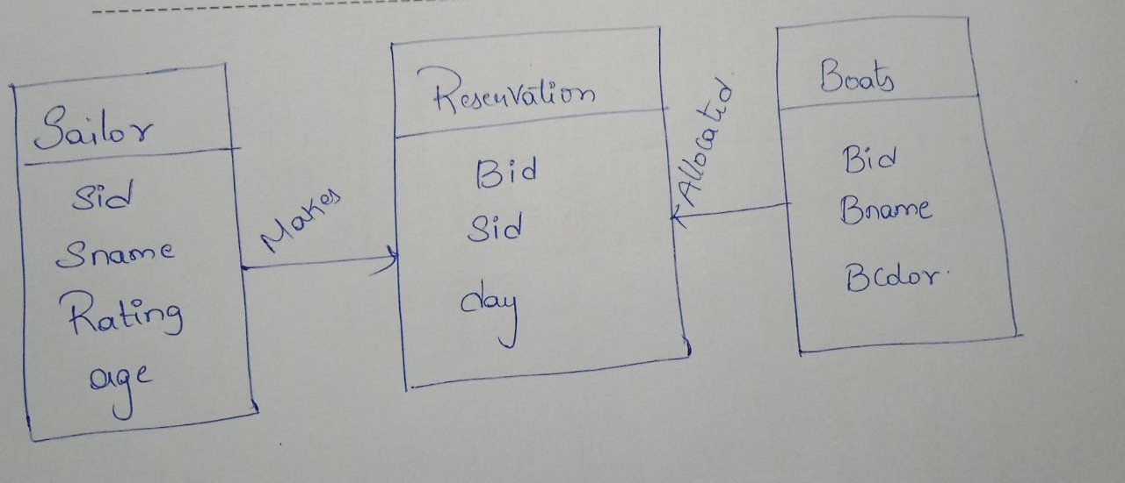

Sid

Sname

Rating

age

Sid

Bid

day

Bid

Bname

Bcolor

**Sailor**

**Reservation**

**Boats**

Makes

allocated